1️⃣ @RestController
- Combines @Controller and @ResponseBody.
- Tells Spring Boot:
“This class will handle HTTP requests and return data directly in the response body (usually JSON).”
- Without it, your class would not be recognized as a REST endpoint provider.
Example:
When you return a cloudVendor object, Spring automatically converts it into JSON — thanks to @RestController.

2️⃣ @RequestMapping("/cloudvendor")
- Defines the base URL path for all endpoints inside this controller.
- This means every mapping in this class will start with /cloudvendor.
So:
- GET /cloudvendor/{vendorID}
- POST /cloudvendor
- PUT /cloudvendor
- DELETE /cloudvendor/{vendorID}
will all map to methods inside this class.

🧭 Inside the class
cloudVendor cloudvendor;
- This is just a variable (temporary storage).
- It’s not connected to a database — so data resets when you restart the app.

✳️ GET Mapping
@GetMapping("/{vendorID}")
public cloudVendor getCloudVendorDetials(@PathVariable String vendorID) {
return cloudvendor;
}

3️⃣ @GetMapping("/{vendorID}")
- Maps HTTP GET requests to this method.
- /{vendorID} means the endpoint expects a path variable (like /cloudvendor/C1).

4️⃣ @PathVariable
- Extracts the value from the URL and passes it to the method.
- Example:
GET http://localhost:8080/cloudvendor/C1
→ Spring sets vendorID = "C1"
Currently, the method just returns the stored cloudvendor object.

✳️ POST Mapping
@PostMapping
public String createCloudVendorDetials(@RequestBody cloudVendor cloudvendor) {
this.cloudvendor = cloudvendor;
return "Cloud Vendor Created Sucessfully";
}

5️⃣ @PostMapping
- Maps HTTP POST requests (used for creating resources).
- Example endpoint:
POST http://localhost:8080/cloudvendor

6️⃣ @RequestBody
- Converts incoming JSON data into a Java object automatically.
- Example JSON body:
{
"vendorID": "C1",
"vendorName": "Nisha",
"vendorGender": "Female",
"vendorAge": "30",
"vendorContact": "8369"
}
→ Spring Boot automatically maps it to a cloudVendor Java object.

✳️ PUT Mapping
@PutMapping
public String updateCloudVendorDetials(@RequestBody cloudVendor cloudvendor) {
this.cloudvendor = cloudvendor;
return "Cloud Vendor Updated Sucessfully";
}

7️⃣ @PutMapping
- Handles HTTP PUT requests — used for updating existing data.
- Works similar to @PostMapping, but conceptually for updates.

✳️ DELETE Mapping
@DeleteMapping("/{vendorID}")
public String DeleteCloudVendorDetials(String vendorID) {
this.cloudvendor = null;
return "Cloud Vendor Deleted Sucessfully";
}

8️⃣ @DeleteMapping("/{vendorID}")
- Handles HTTP DELETE requests.
- Path /cloudvendor/{vendorID} indicates which record to delete.
Note ⚠️:
You should also use @PathVariable here:
public String DeleteCloudVendorDetials(@PathVariable String vendorID)
Otherwise, vendorID won’t be populated from the URL.

🧱 1️⃣ @Entity

🧠 What it does:
@Entity marks a Java class as a JPA entity — meaning it represents a table in your database.
When you use JPA (Hibernate), it automatically maps your class to a table.

🧩 Example:
import jakarta.persistence.Entity;
import jakarta.persistence.Id;

@Entity
public class CloudVendor {
@Id
private String vendorId;
private String vendorName;
private String vendorAddress;
private String vendorPhoneNumber;

// Getters and Setters
}

💬 Explanation:
- The class CloudVendor becomes a database table (for example, cloud_vendor).
- Each field becomes a column.
- @Id marks the primary key of the table.

🧾 2️⃣ @Table

🧠 What it does:
@Table lets you customize the table name and schema mapping of your entity.

🧩 Example:
import jakarta.persistence.Entity;
import jakarta.persistence.Table;
import jakarta.persistence.Id;

@Entity
@Table(name = "vendors")
public class CloudVendor {
@Id
private String vendorId;
private String vendorName;
}

💬 Explanation:
Without @Table, Hibernate would create a table called cloud_vendor by default.
With @Table(name = "vendors"), you explicitly tell Hibernate to use the table name vendors.

🔑 3️⃣ @Id

🧠 What it does:
@Id marks a field as the primary key of your entity (the unique identifier).

🧩 Example:
@Entity
public class CloudVendor {
@Id
private String vendorId;
private String vendorName;
}

💬 Optional — You can generate it automatically:
@Id
@GeneratedValue(strategy = GenerationType.IDENTITY)
private Long id;
→ Hibernate will auto-generate primary key values (like auto-increment in SQL).

⚙️ 4️⃣ @Service

🧠 What it does:
@Service marks a class as a business logic layer component.
It tells Spring:
“This is where my service/business logic lives — please create a Spring Bean for it.”
It’s part of Spring’s stereotype annotations, along with:
- @Component (generic)
- @Service (business logic)
- @Repository (database access)
- @Controller (web layer)

🧩 Example:
import org.springframework.stereotype.Service;
import java.util.*;

@Service
public class CloudVendorService {
private Map<String, String> vendorData = new HashMap<>();

public String getVendorById(String vendorId) {
return vendorData.get(vendorId);
}

public void addVendor(String id, String name) {
vendorData.put(id, name);
}
}

💬 Explanation:
- Spring will detect this class during component scanning.
- You can inject it into controllers using @Autowired.
@Autowired
private CloudVendorService cloudVendorService;

🚦 5️⃣ @ControllerAdvice

🧠 What it does:
@ControllerAdvice is a global exception handler for your Spring MVC controllers.
It lets you handle exceptions in one place instead of writing try-catch blocks in every controller.

🧩 Example:
import org.springframework.http.HttpStatus;
import org.springframework.http.ResponseEntity;
import org.springframework.web.bind.annotation.ControllerAdvice;
import org.springframework.web.bind.annotation.ExceptionHandler;

@ControllerAdvice
public class GlobalExceptionHandler {

// Handle a specific exception
@ExceptionHandler(ResourceNotFoundException.class)
public ResponseEntity<String> handleNotFound(ResourceNotFoundException ex) {
return new ResponseEntity<>("❌ " + ex.getMessage(), HttpStatus.NOT_FOUND);
}

// Handle generic exceptions
@ExceptionHandler(Exception.class)
public ResponseEntity<String> handleException(Exception ex) {
return new ResponseEntity<>("⚠️ Something went wrong: " + ex.getMessage(),
HttpStatus.INTERNAL_SERVER_ERROR);
}
}

⚠️ 6️⃣ @ExceptionHandler

🧠 What it does:
@ExceptionHandler is used inside a @ControllerAdvice or directly in a controller to handle specific exceptions.

🧩 Example:
Inside a controller:
@GetMapping("/vendor/{id}")
public ResponseEntity<String> getVendor(@PathVariable String id) {
if (id.equals("404")) {
throw new ResourceNotFoundException("Vendor not found!");
}
return ResponseEntity.ok("Vendor found!");
}

@ExceptionHandler(ResourceNotFoundException.class)
public ResponseEntity<String> handleNotFound(ResourceNotFoundException ex) {
return new ResponseEntity<>("❌ " + ex.getMessage(), HttpStatus.NOT_FOUND);
}
💬 Explanation:
When ResourceNotFoundException is thrown, this method catches it and returns a custom HTTP 404 response.

🧩 Combined Example (All Together)

💻 CloudVendor.java
import jakarta.persistence.Entity;
import jakarta.persistence.Id;
import jakarta.persistence.Table;

@Entity
@Table(name = "cloud_vendor")
public class CloudVendor {
@Id
private String vendorId;
private String vendorName;
private String vendorAddress;
private String vendorPhoneNumber;

// Getters and Setters
}

💻 CloudVendorService.java
import org.springframework.stereotype.Service;
import java.util.*;

@Service
public class CloudVendorService {
private Map<String, CloudVendor> vendorList = new HashMap<>();

public CloudVendor getVendor(String vendorId) {
CloudVendor vendor = vendorList.get(vendorId);
if (vendor == null) throw new ResourceNotFoundException("Vendor not found: " + vendorId);
return vendor;
}

public void addVendor(CloudVendor vendor) {
vendorList.put(vendor.getVendorId(), vendor);
}
}

💻 GlobalExceptionHandler.java
import org.springframework.http.*;
import org.springframework.web.bind.annotation.*;

@ControllerAdvice
public class GlobalExceptionHandler {

@ExceptionHandler(ResourceNotFoundException.class)
public ResponseEntity<String> handleNotFound(ResourceNotFoundException ex) {
return new ResponseEntity<>(ex.getMessage(), HttpStatus.NOT_FOUND);
}
}

🧠 TL;DR Summary
Annotation | Layer | Purpose | Example
@Entity | Model | Marks a class as DB table | @Entity class CloudVendor
@Table | Model | Customize table name | @Table(name="vendors")
@Id | Model | Primary key | @Id Long id
@Service | Service | Business logic bean | @Service class VendorService
@ControllerAdvice | Global | Centralized exception handling | @ControllerAdvice class GlobalHandler
@ExceptionHandler | Global/Controller | Handle specific exceptions | @ExceptionHandler(Exception.class)

@Component is an annotation used to mark a Java class as a Spring-managed bean.
It tells the Spring IoC (Inversion of Control) container to automatically detect, instantiate, and manage that class.
When you annotate a class with @Component, Spring will:
- Create an object of that class.
- Store it in the Spring Application Context (like a container).
- Allow you to inject it anywhere else using @Autowired.
IOC- Inversion of control--> principal
Dependency Injection--> design pattern
Sprin framework
--> creation of an object.
Springboot
--> confrigutaion take care of it.
--> opionented framework
-->embedded tomcat(craeate a jar file)
--> depend on use case we choice dependency from the spring intializer
--> SpringApplication.run(RestDemo2Application.class, args);--> run the container
--> if we creating r project without springboot we need to do configruation such a spring.xml and add the required dependency manually from maven site and paste it into pom.xml files
--> from application context we are getting IoC container but not the object. So, if we want the object we will write in the spring.xml. In spring.xml we will write the beans. It wiill craete an object of the class.
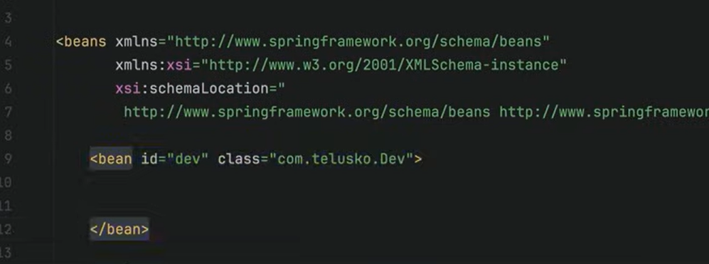

-->if a variable is private and we need to access it in another class, we need to create getter and setter for that.
--> <property> tag is used to set the value of vairable which is private in another class n need to set tha of varaiable by spring . So, we use property<setter injection>
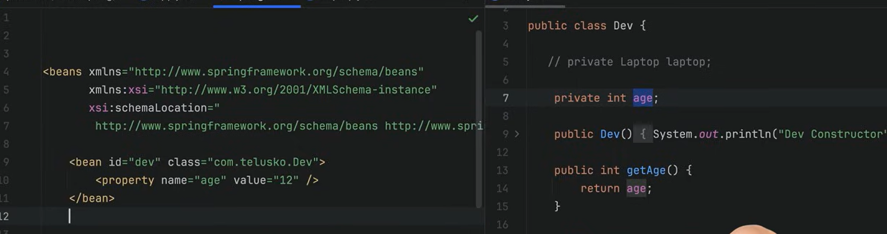
--> constructor injection--> use constructor arg--> injecting the value of variable (age) with constructor

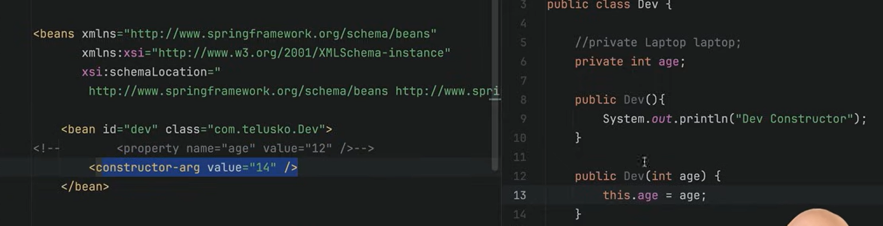
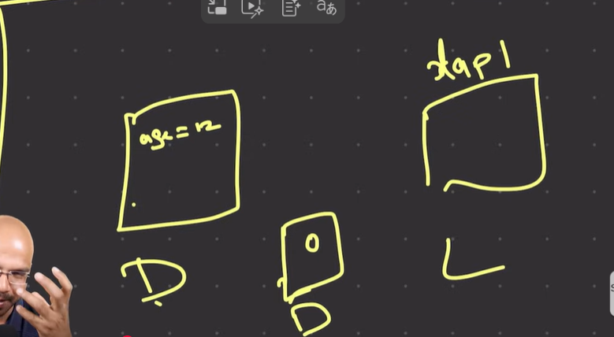
if we want to get an object of the other class that is laptop in dev class. We can say connection two class with the help of beans. So here we do that
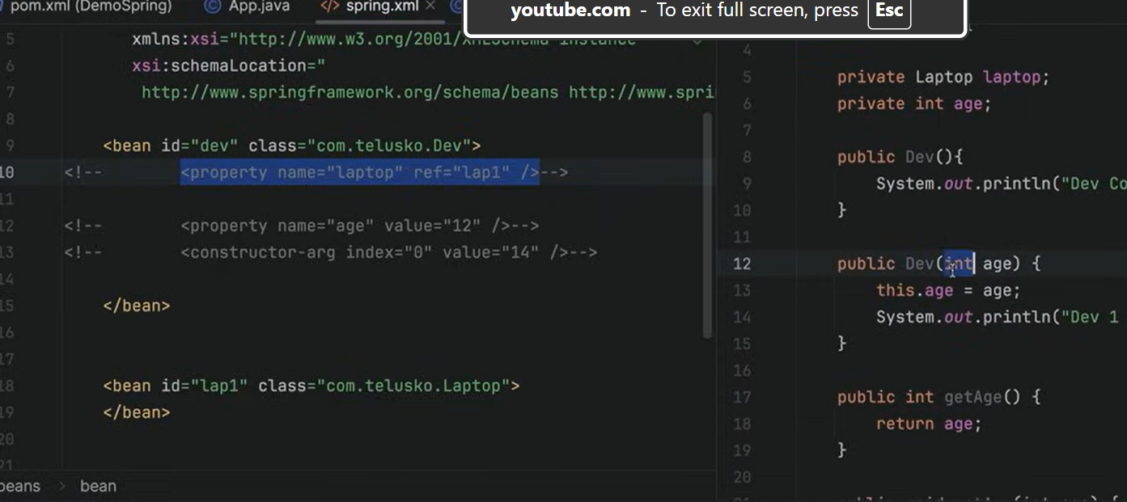
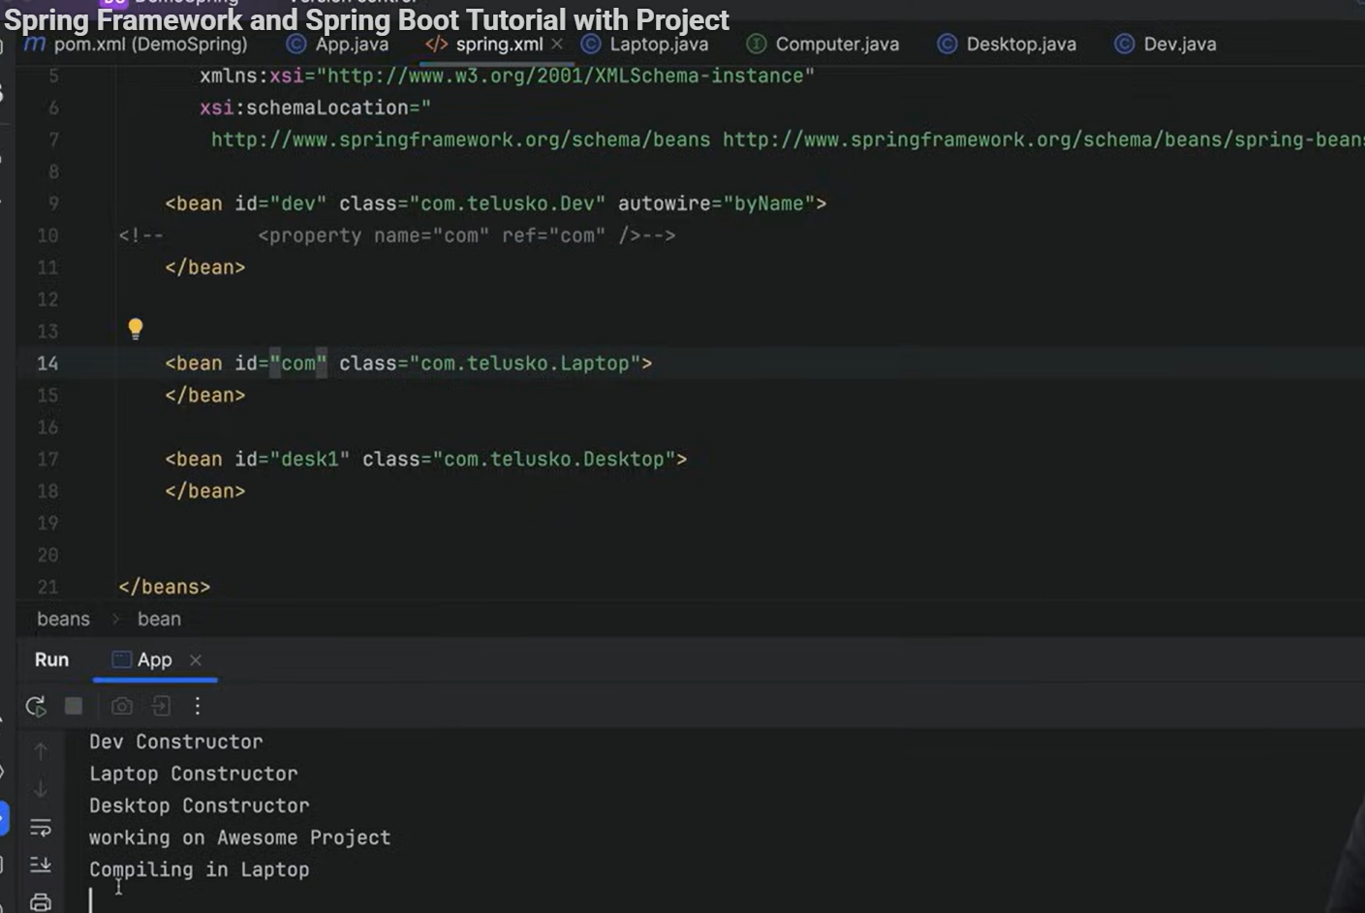
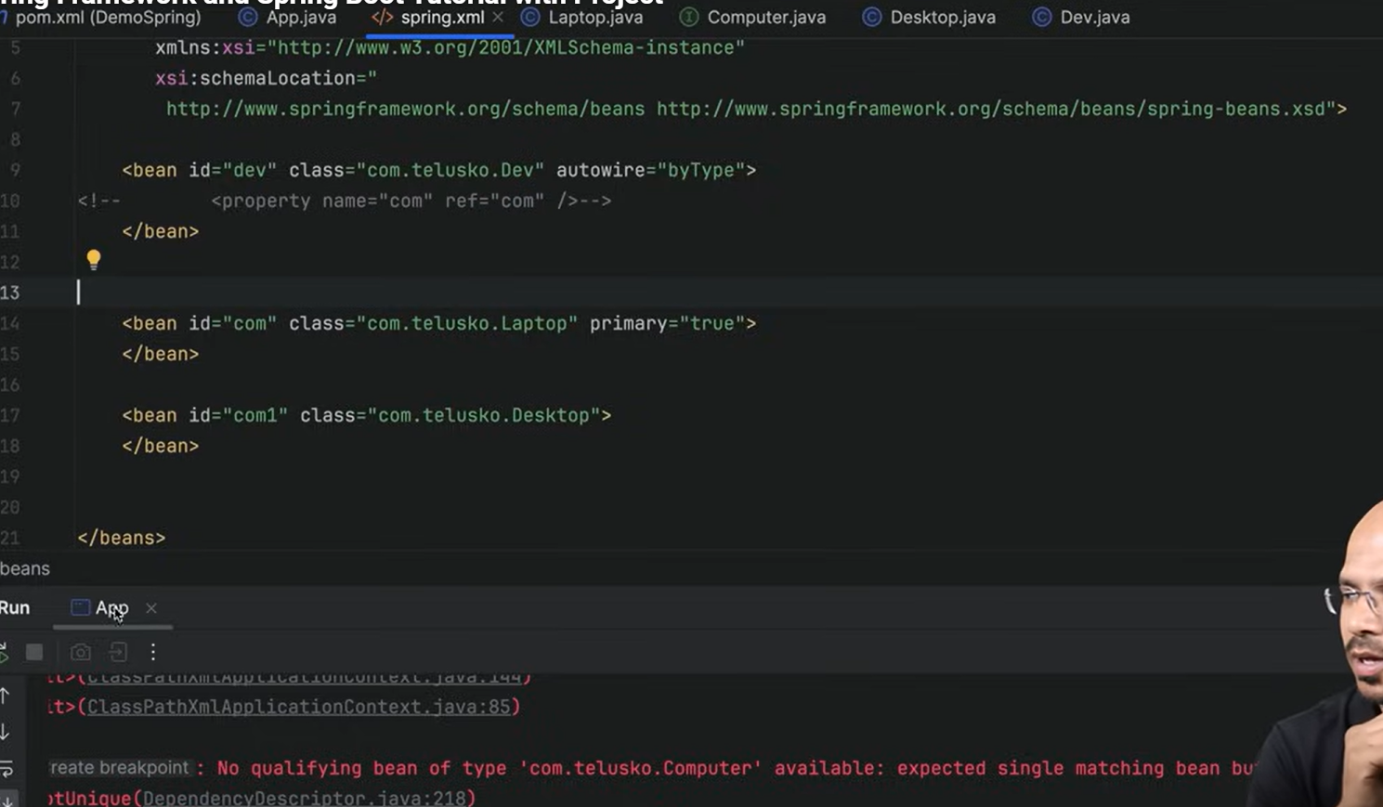
@Autowired is an annotation used by Spring Framework for Dependency Injection (DI).
It tells Spring to automatically inject (supply) the required dependency into a class at runtime.
When Spring Boot starts:
- It scans all classes with @Component (via Component Scanning).
- It creates one object (bean) for each.
- Wherever it sees @Autowired, it injects the matching bean automatically.
For filed injection and setter injection you have you write @Autowired but, for construdtor we have default no need to specify.
It go by type.

JSON- Javascrpit Object Notion

ORM--> object relation mapping
data and behaviour.(productId, ProductName and ProductPrice)
Give object to ORM ,
ORM tool-->create table ,insert the data. Each object is one row.
Hibernate,Esciplse Link
JPA--> Java Persistence API(follow the same standerd)
Spring data JPA

Problem: Multiple Beans of the Same Type
Suppose you have two beans of the same type in Spring:
import org.springframework.stereotype.Component;

@Component
public class PetrolEngine implements Engine {
public void start() {
System.out.println("Petrol engine started...");
}
}

@Component
public class DieselEngine implements Engine {
public void start() {
System.out.println("Diesel engine started...");
}
}
Now, in another class:
@Component
public class Car {

@Autowired
private Engine engine; // ❌ Problem — Which engine to inject?
}
Spring will be confused because there are two beans of type Engine.
Result → NoUniqueBeanDefinitionException (Spring doesn’t know which one to use).

✅ Solution 1: Use @Primary
If you want one bean to be the default when there are multiple options —
mark it with @Primary.
@Component
@Primary
public class PetrolEngine implements Engine {
public void start() {
System.out.println("Petrol engine started...");
}
}

@Component
public class DieselEngine implements Engine {
public void start() {
System.out.println("Diesel engine started...");
}
}
Now, if you use:
@Autowired
private Engine engine;
Spring will automatically inject the PetrolEngine (the one marked with @Primary).

🟢 Output:
Petrol engine started...

✅ Solution 2: Use @Qualifier
@Qualifier lets you explicitly specify which bean to inject.
Example:
@Component("petrolEngine")
public class PetrolEngine implements Engine {
public void start() {
System.out.println("Petrol engine started...");
}
}

@Component("dieselEngine")
public class DieselEngine implements Engine {
public void start() {
System.out.println("Diesel engine started...");
}
}
Then in your Car class:
@Component
public class Car {

@Autowired
@Qualifier("dieselEngine") // 👈 specify exact bean name
private Engine engine;

public void drive() {
engine.start();
}
}

🟢 Output:
Diesel engine started...

⚙️ Key Difference
Feature | @Primary | @Qualifier
Purpose | Set a default bean when multiple exist | Choose a specific bean explicitly
Where used | On Bean Class or Bean Method | On injection point (@Autowired)
Priority | Acts as fallback | Overrides @Primary if used together
Usage | General default choice | Specific choice per injection

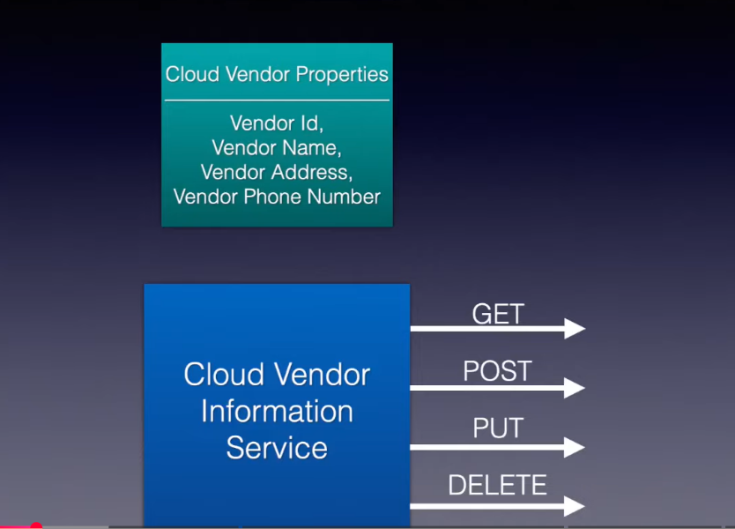
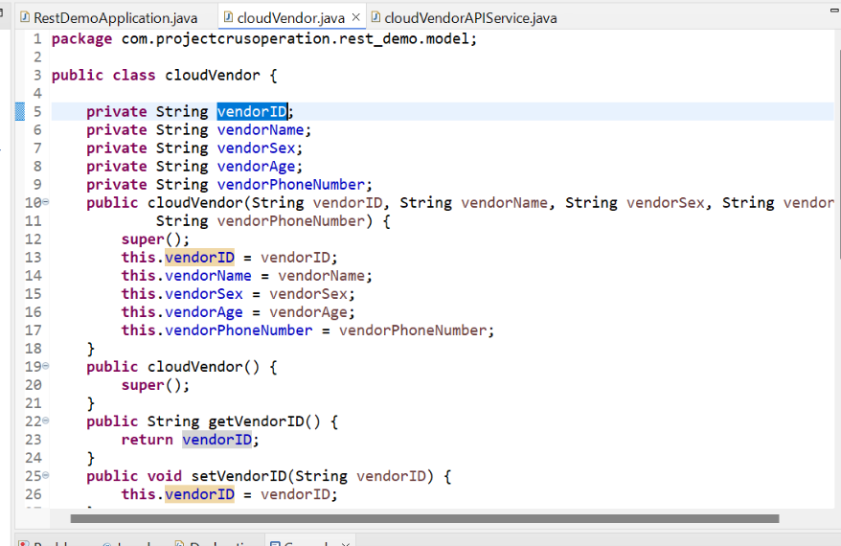
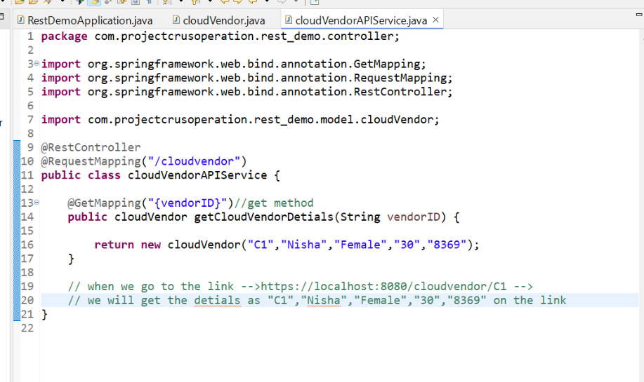
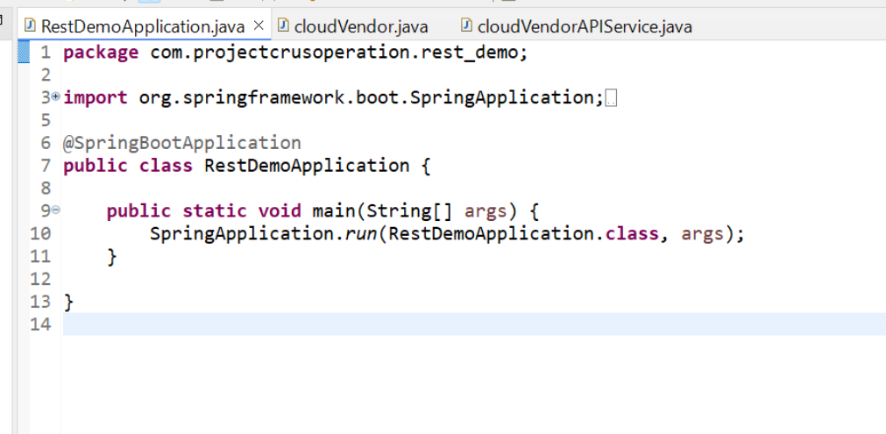

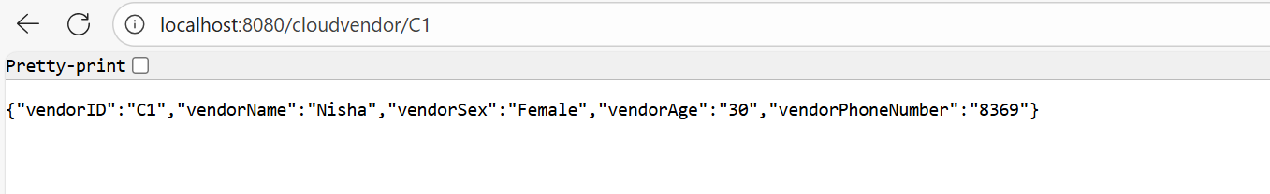
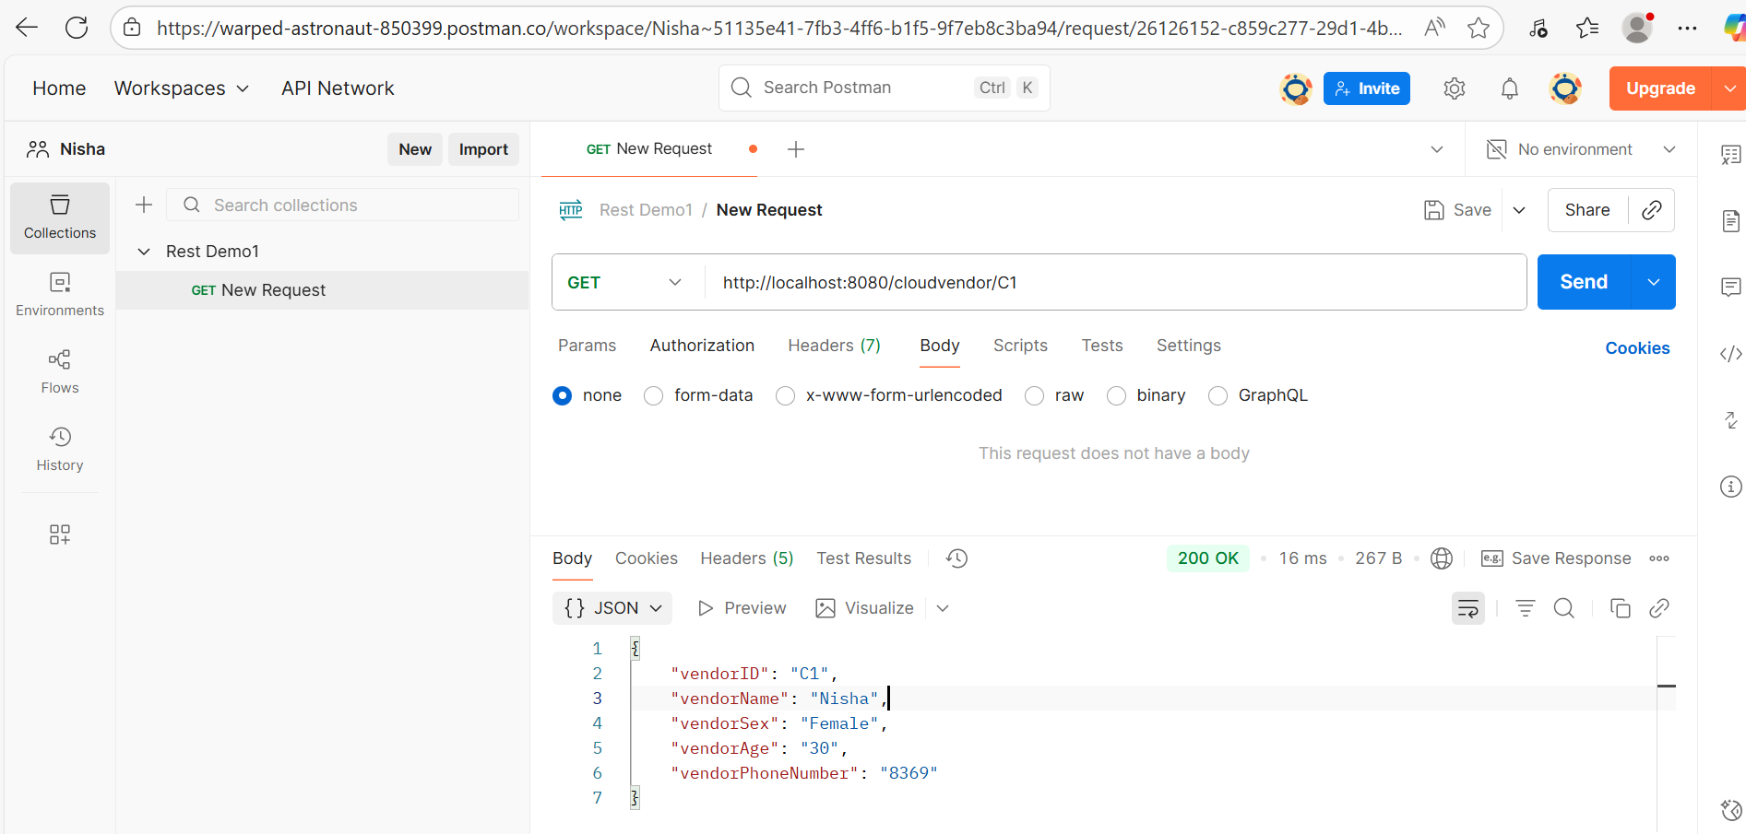
ldfjhksldjkfhsldfkj
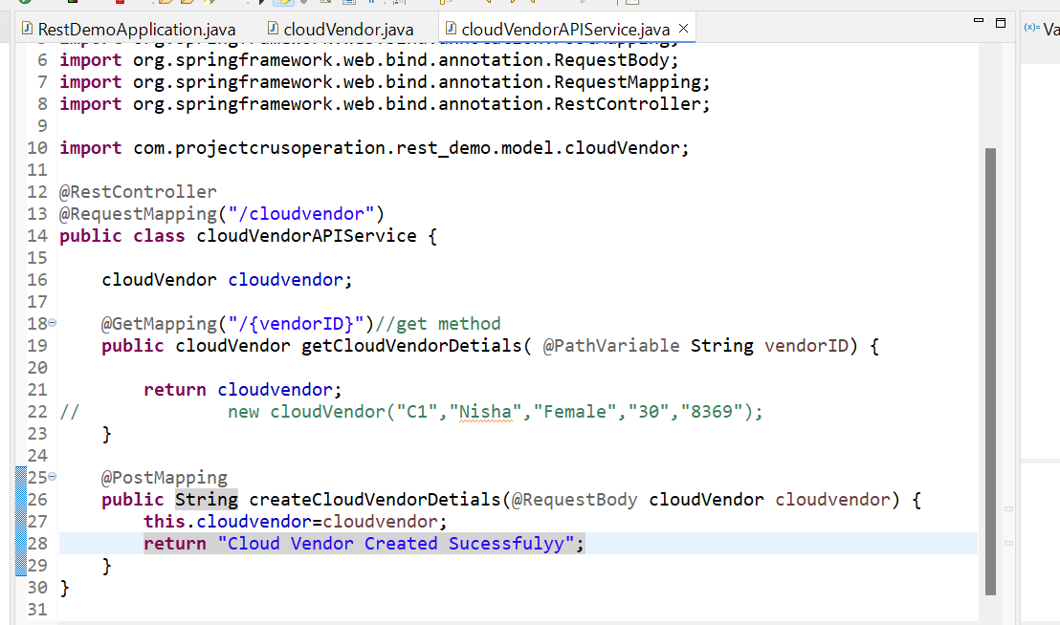

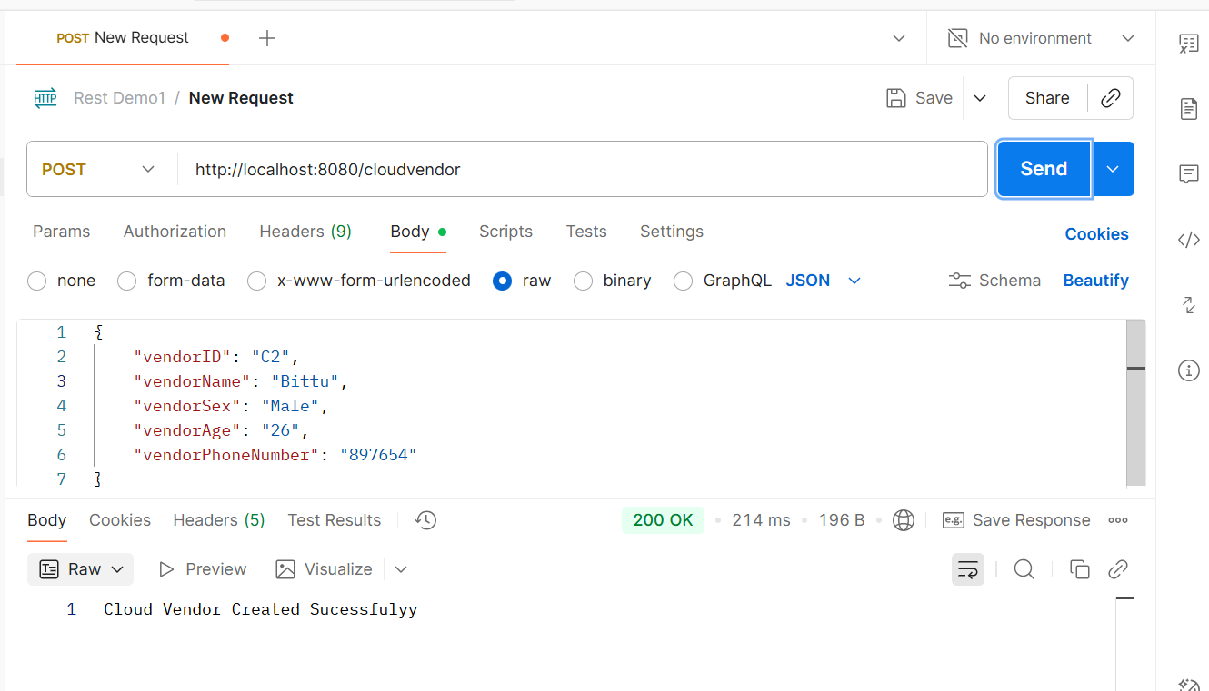
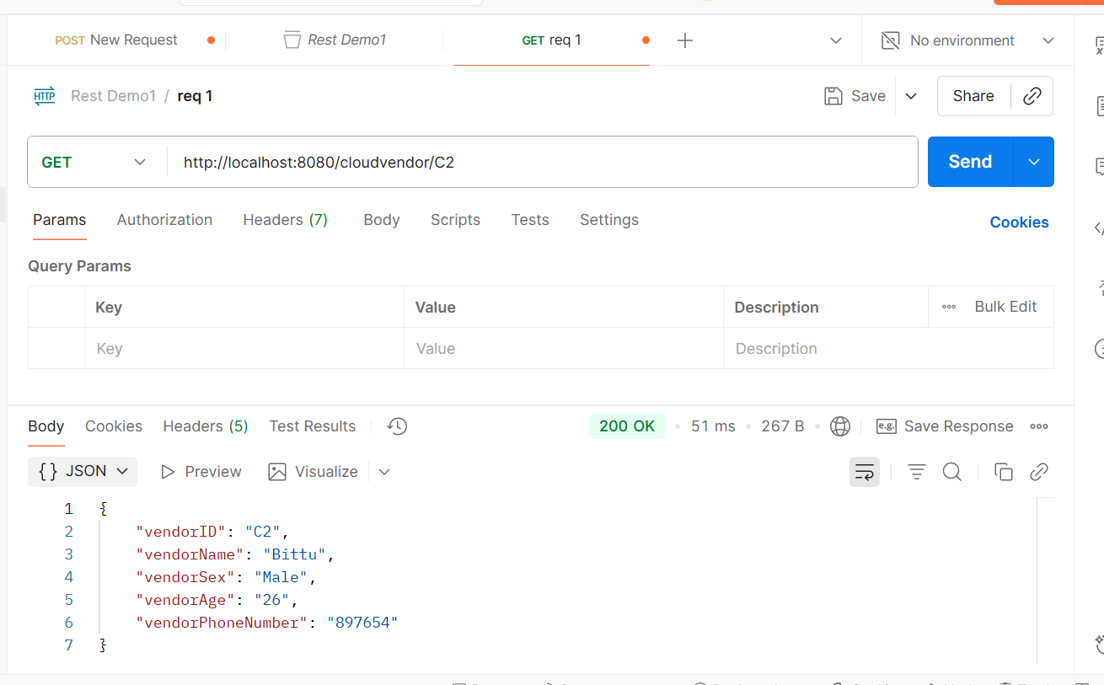
get the request kjfhj

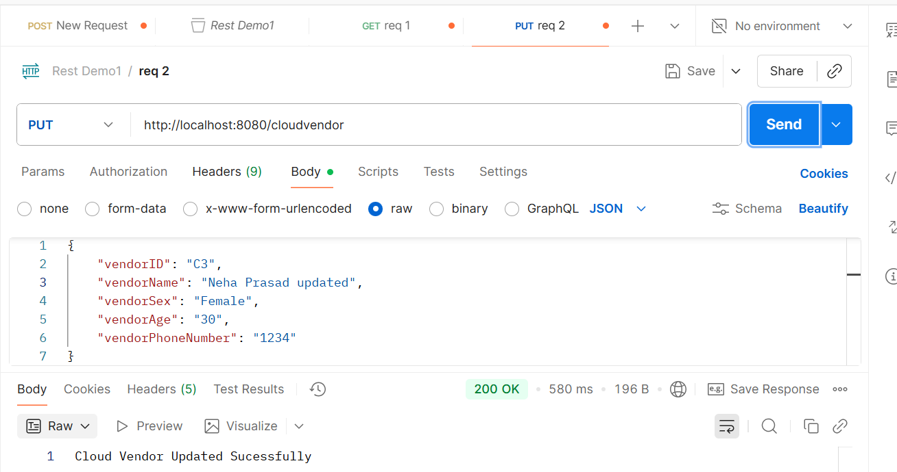
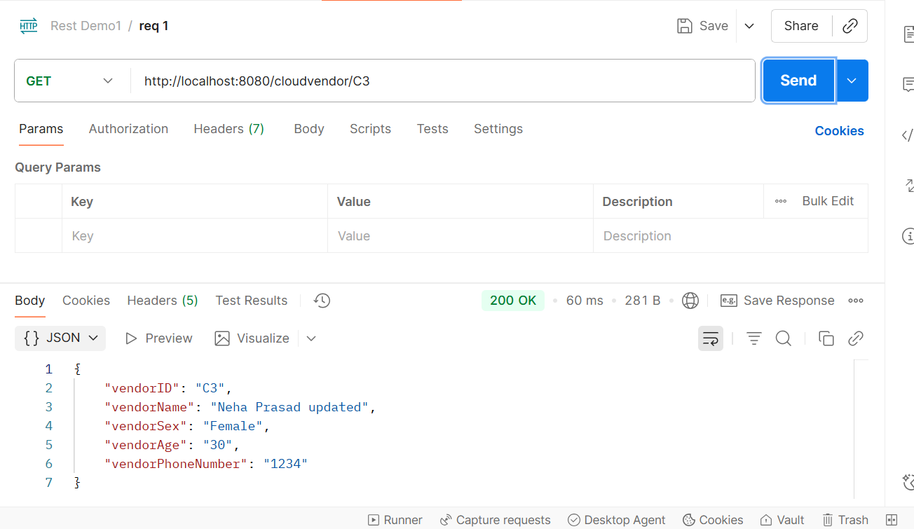
kjhk

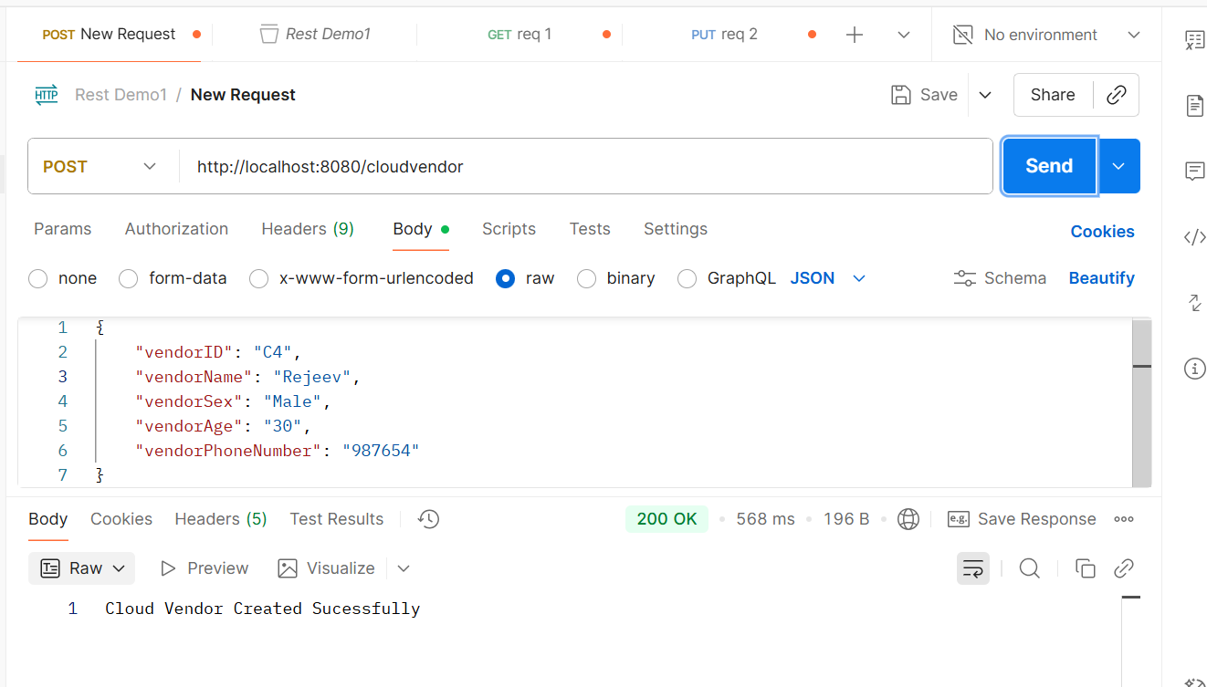
kjhg

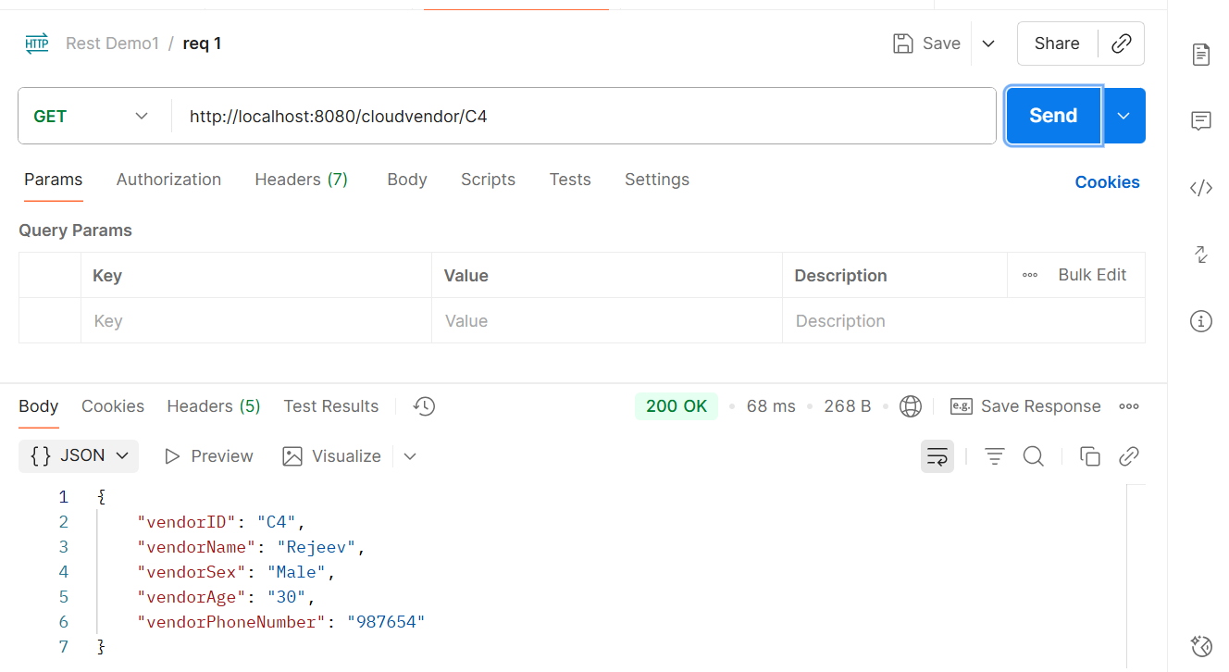
lkjh

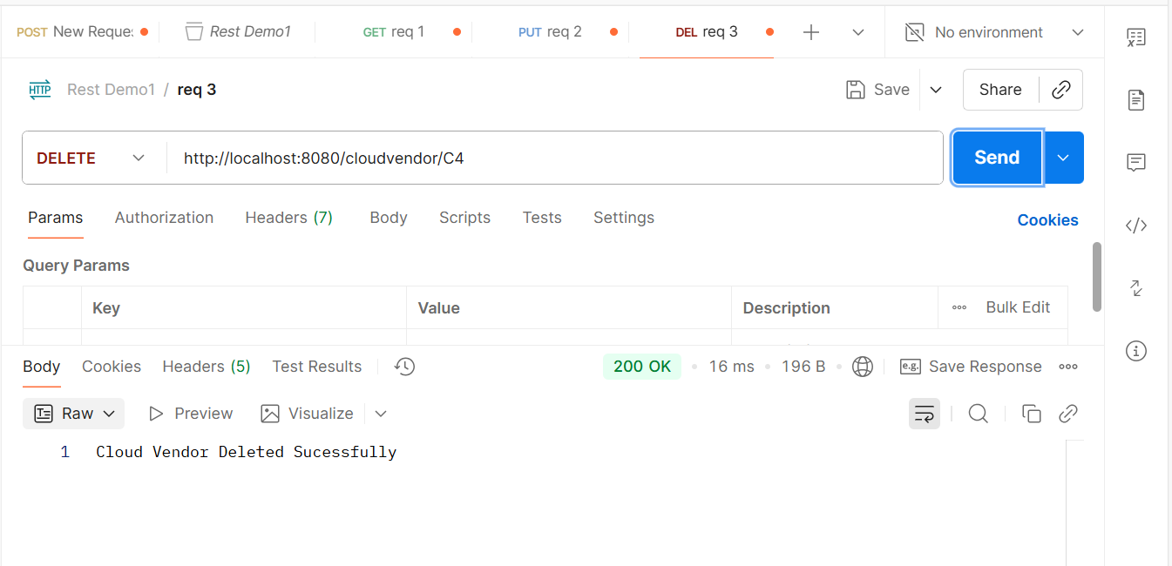
kjgh

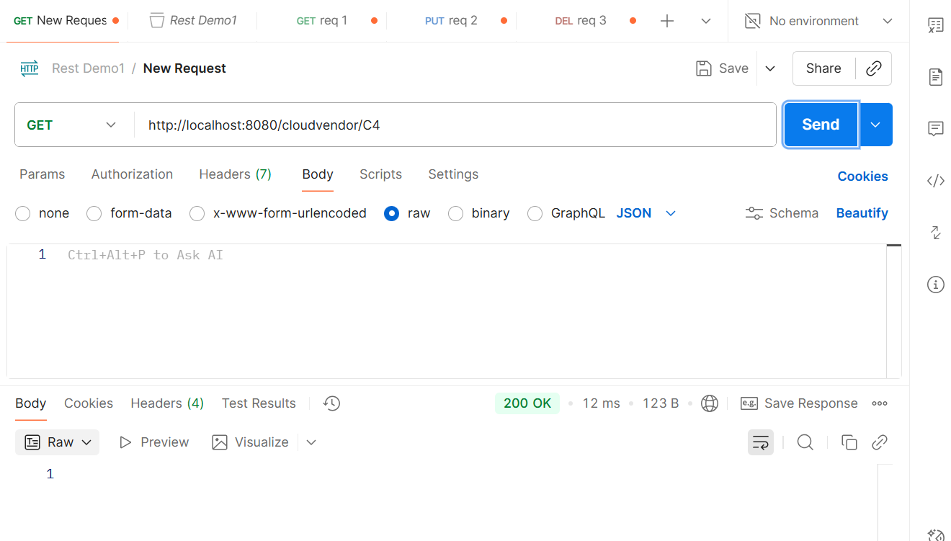
kjhljk

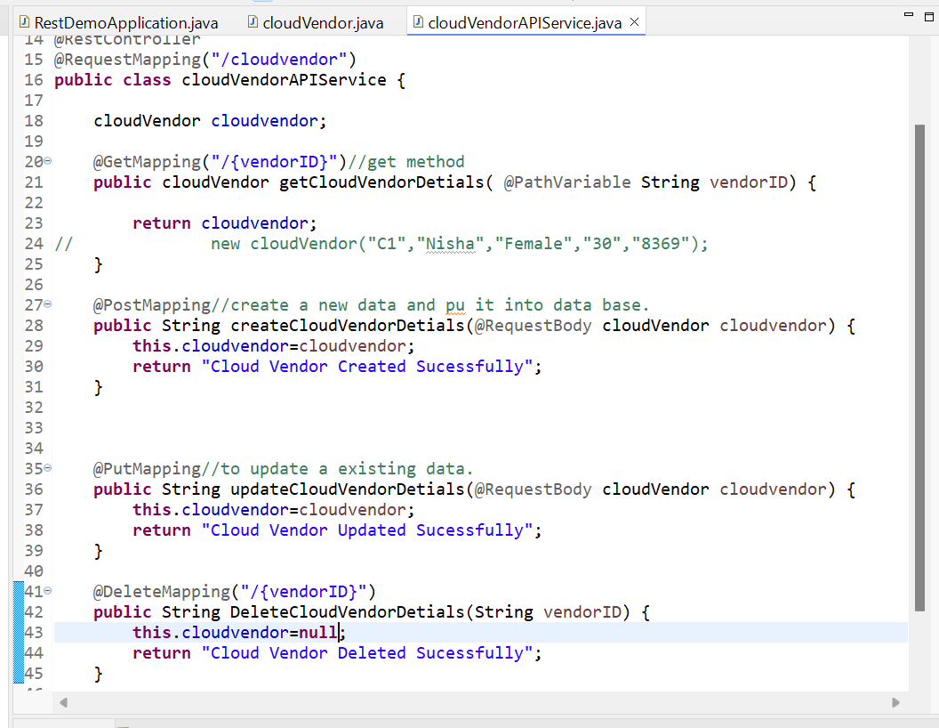
kjhk

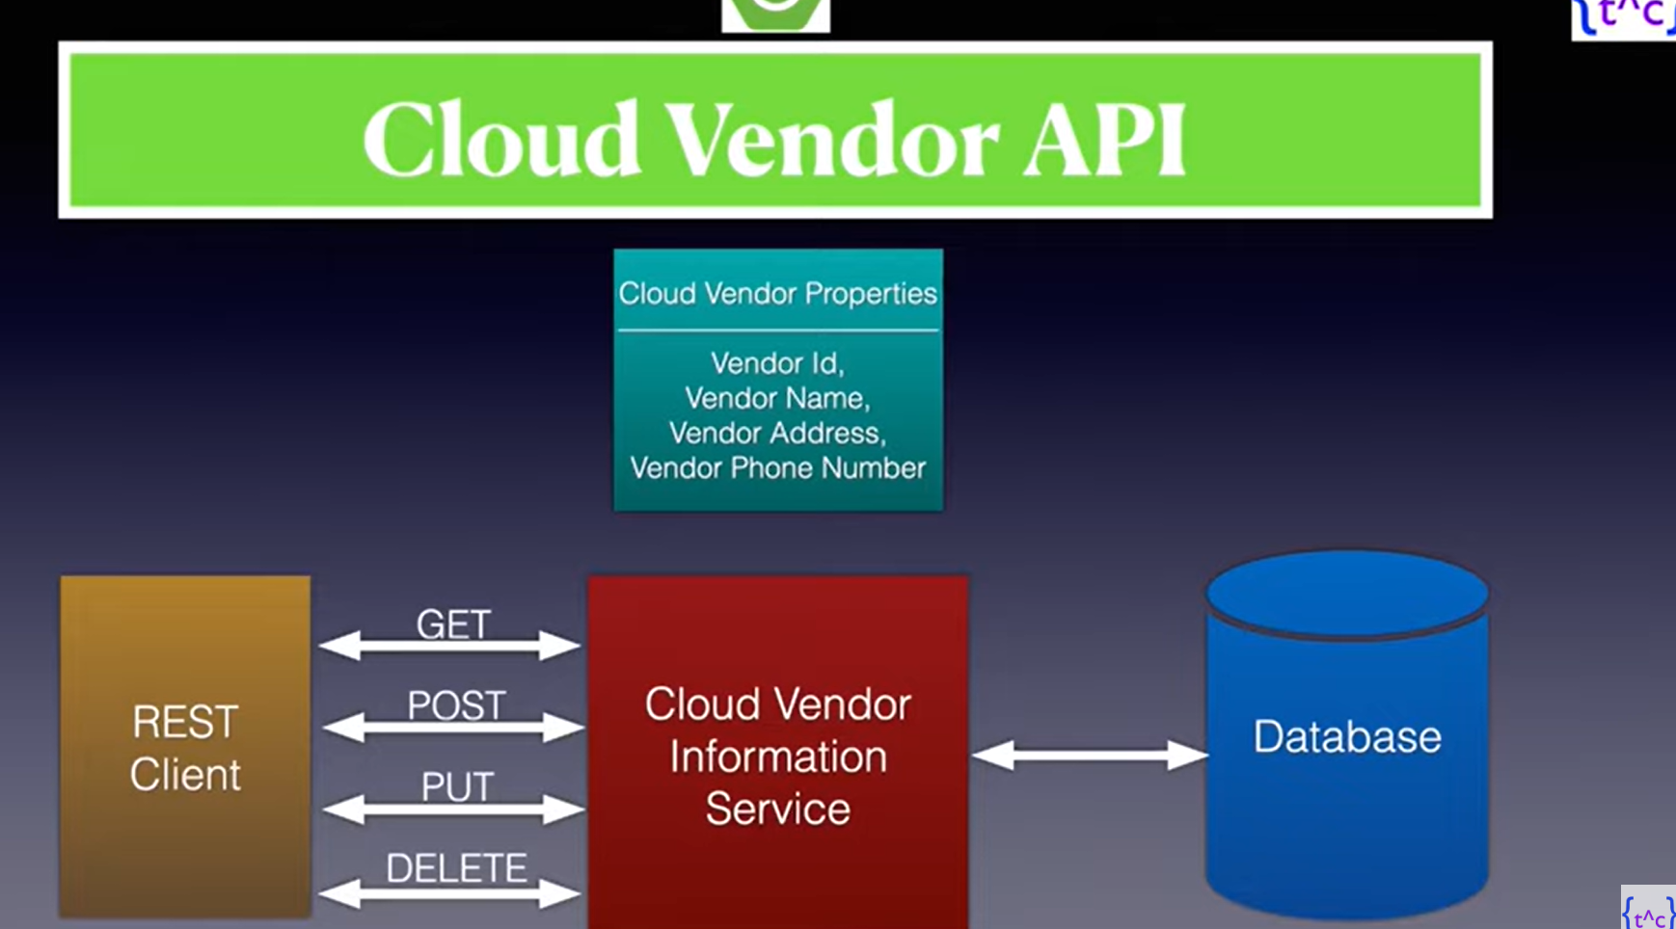
jhk

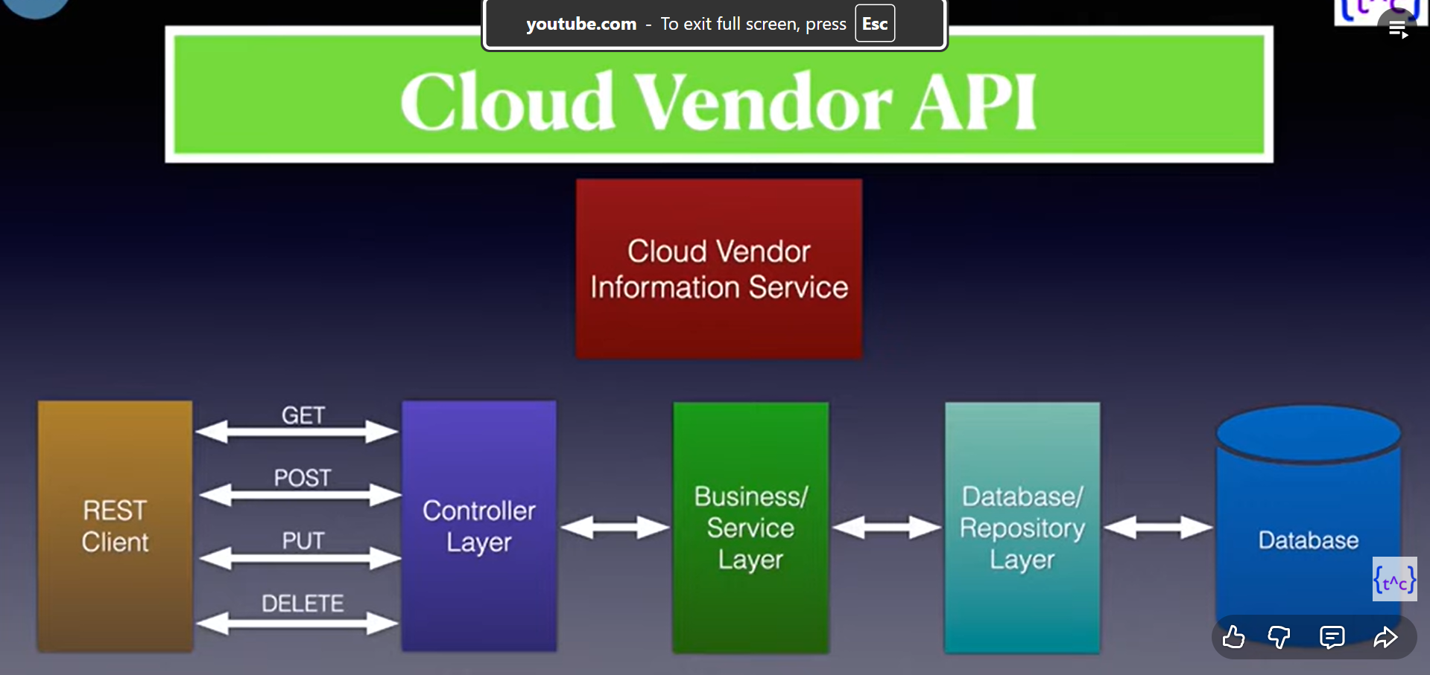
lkhrlfsk

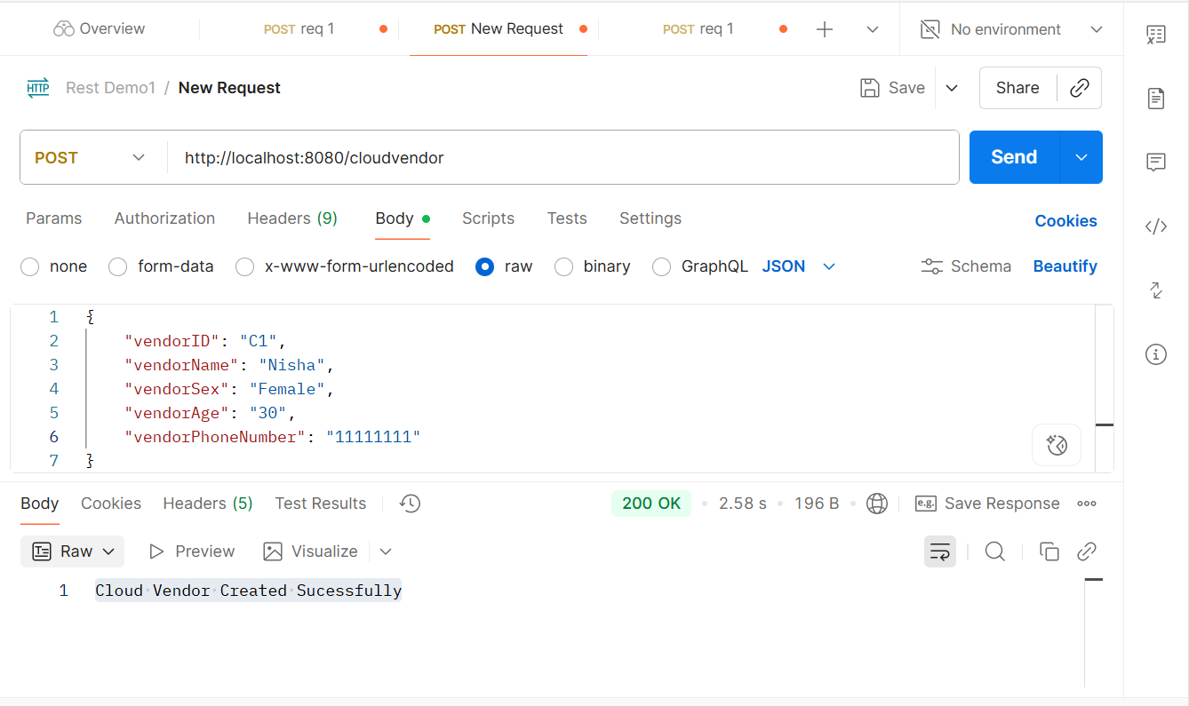
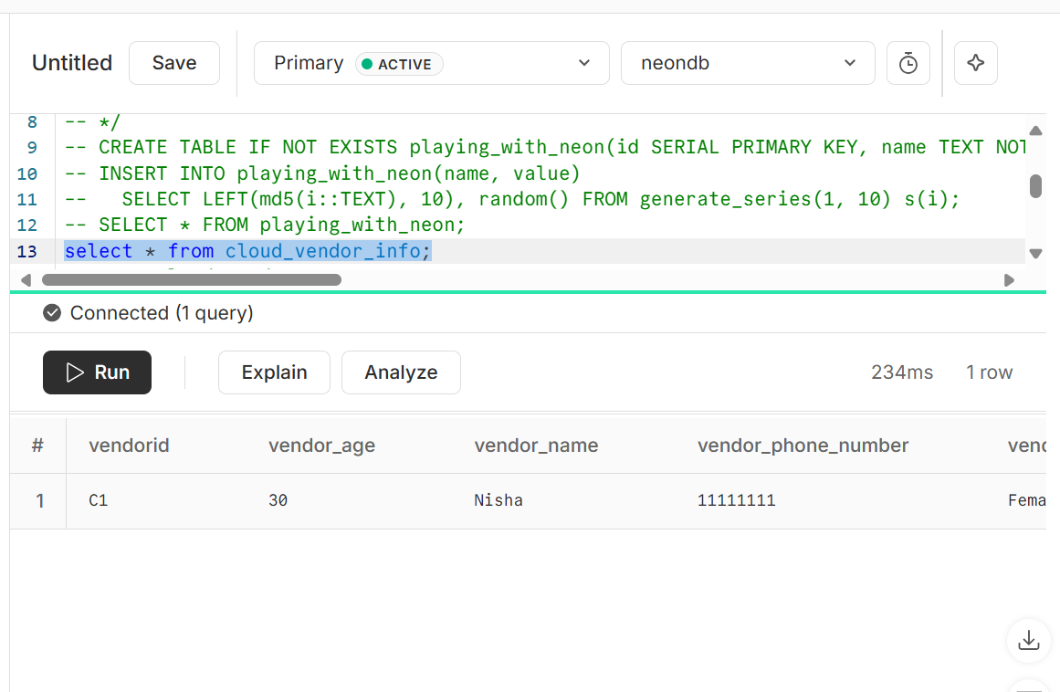
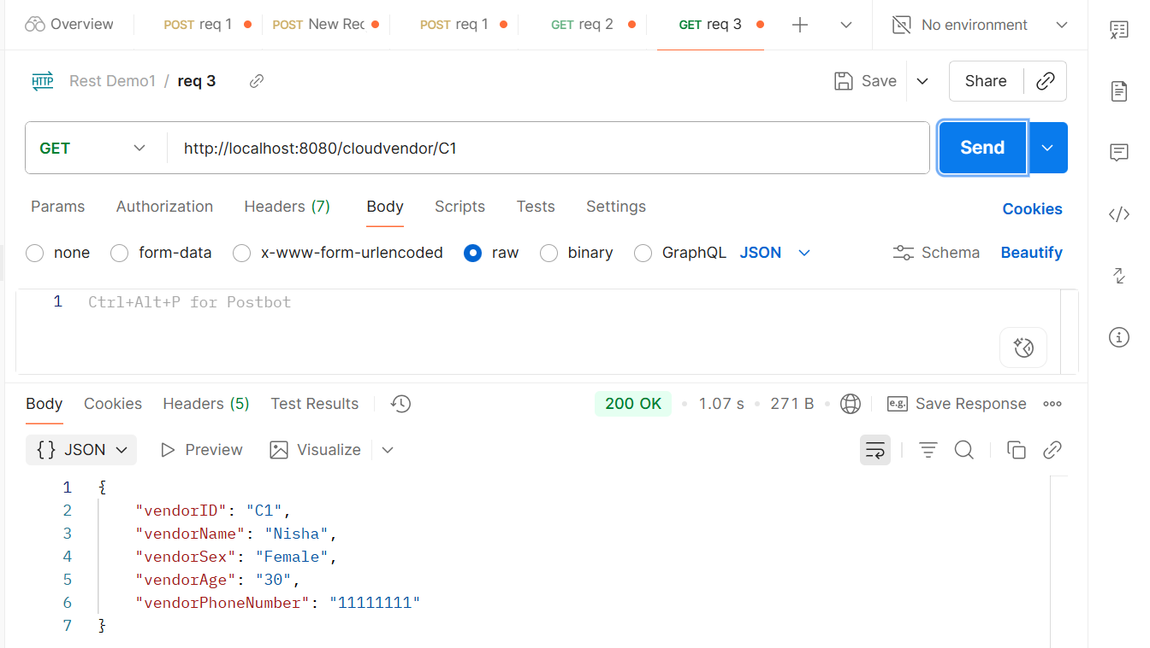
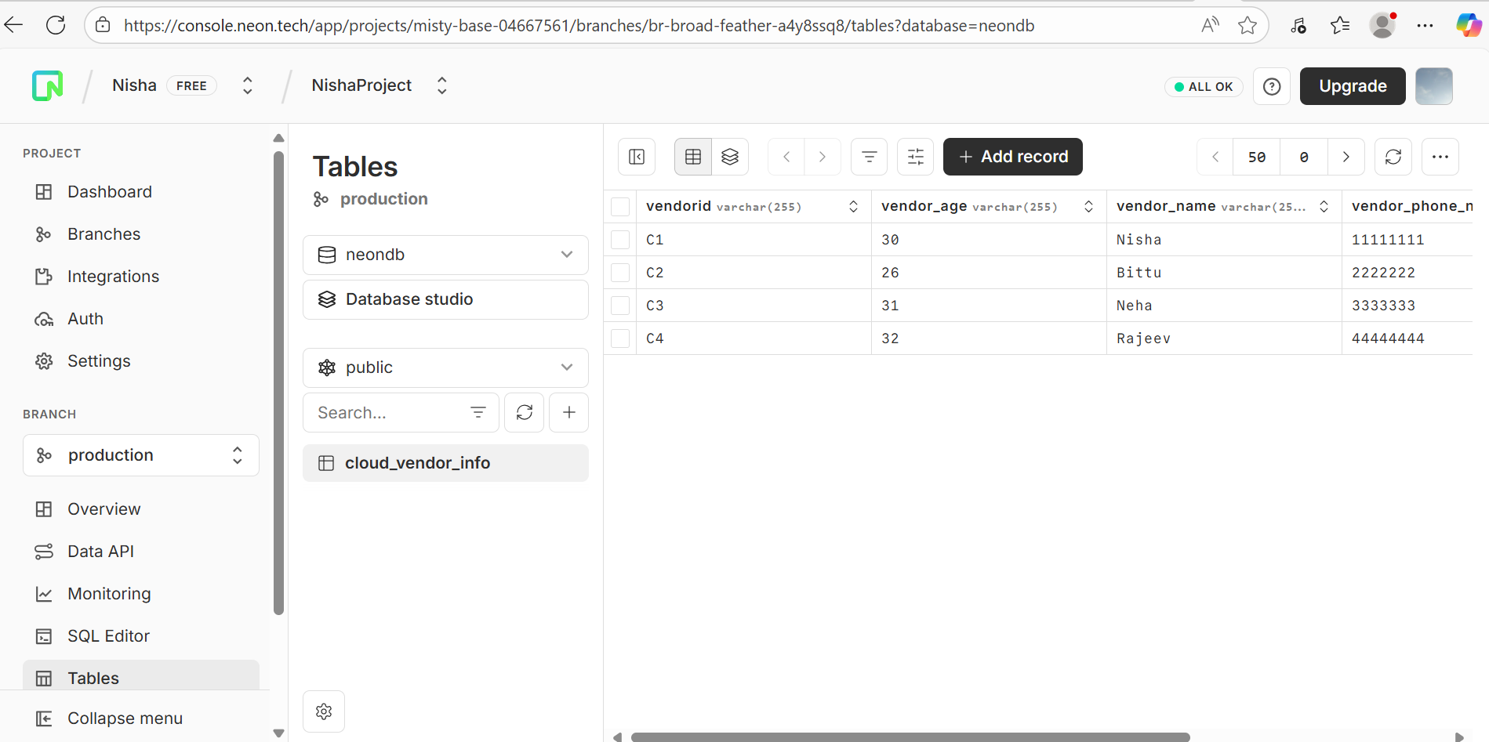
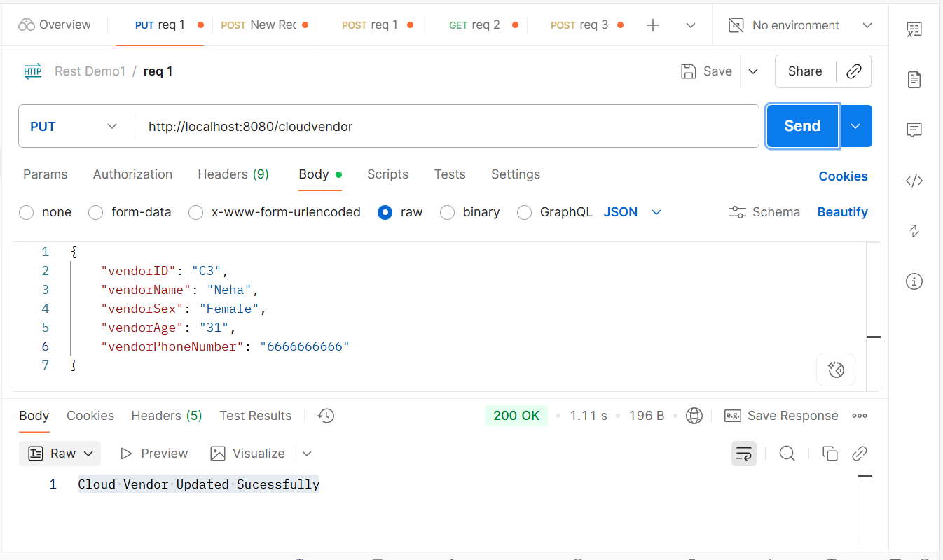
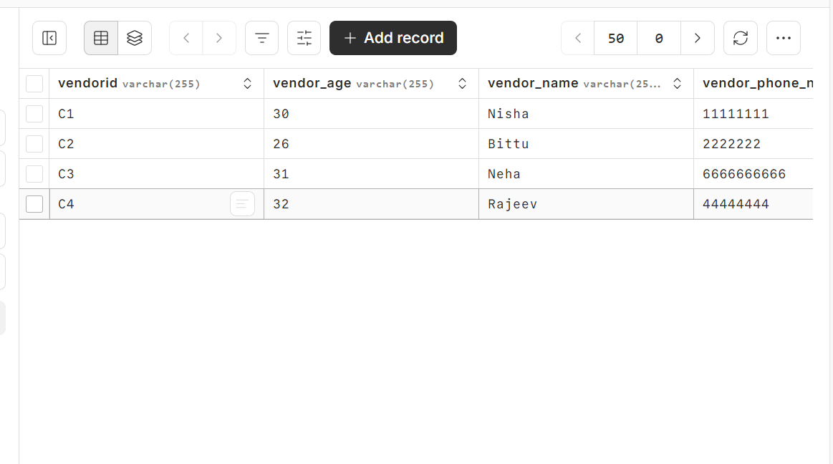
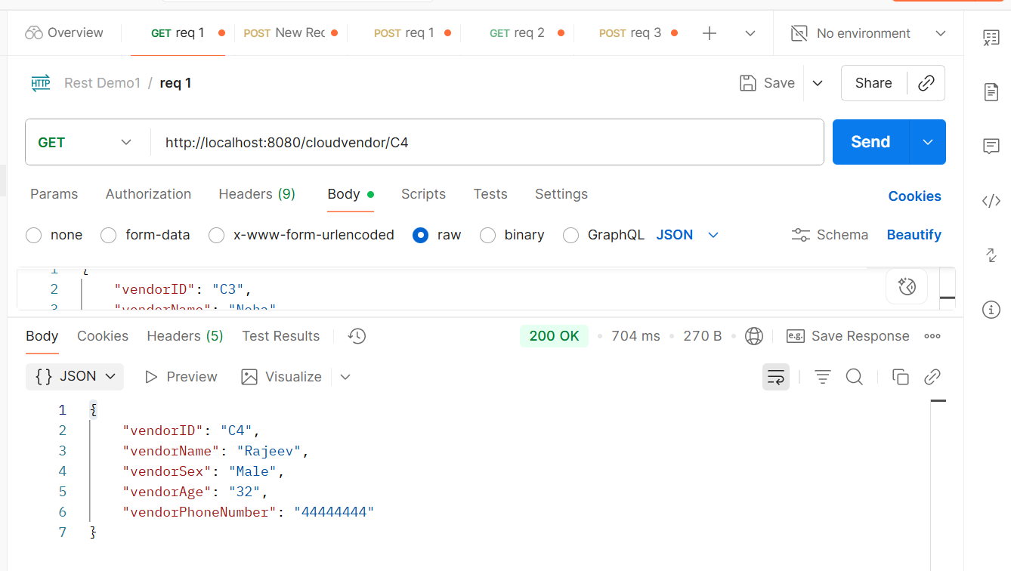
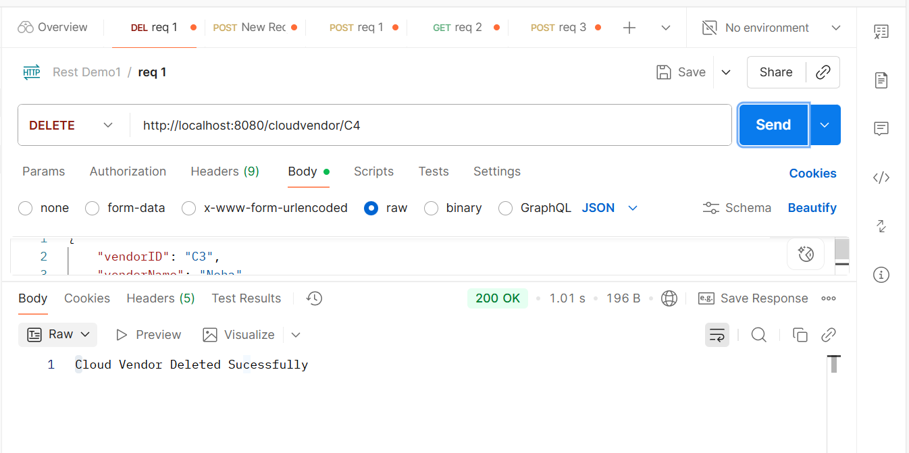
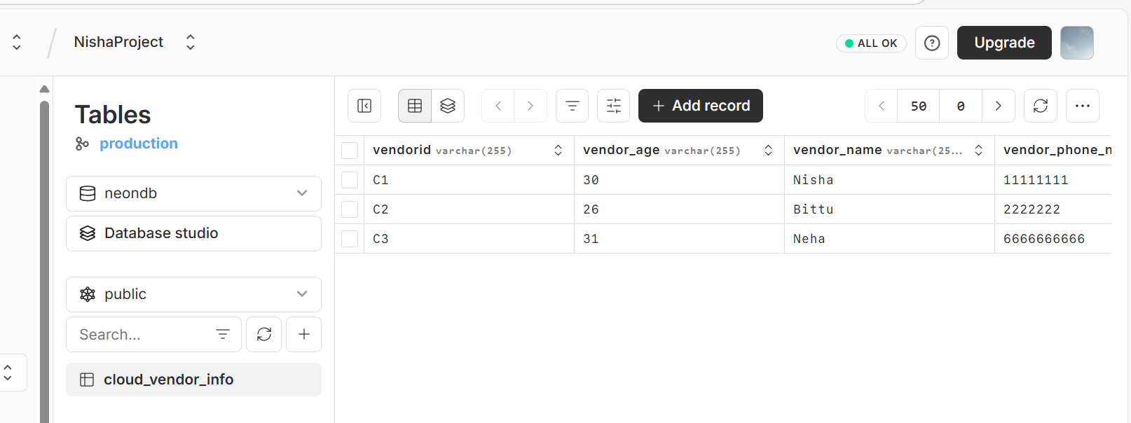
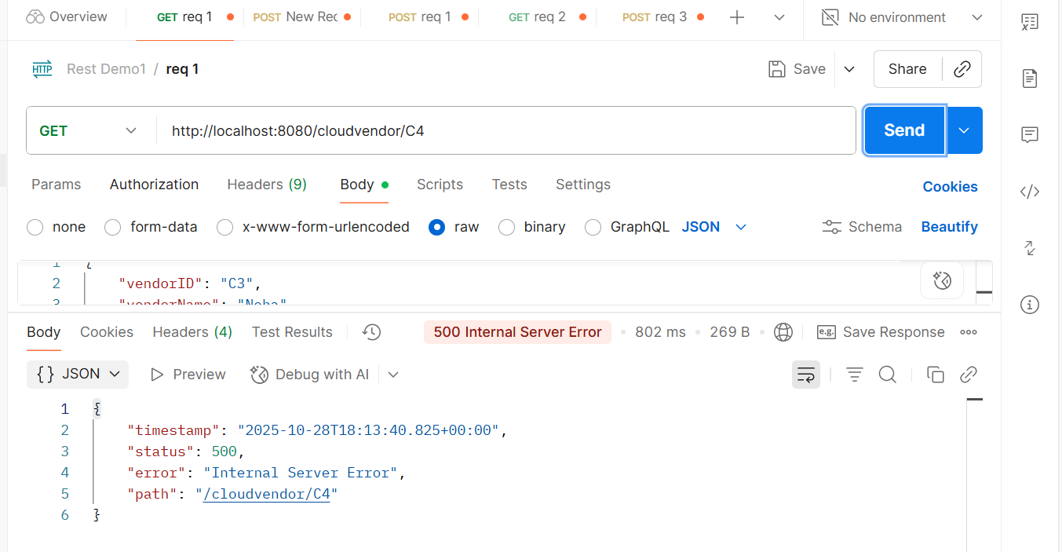
kjgkjh

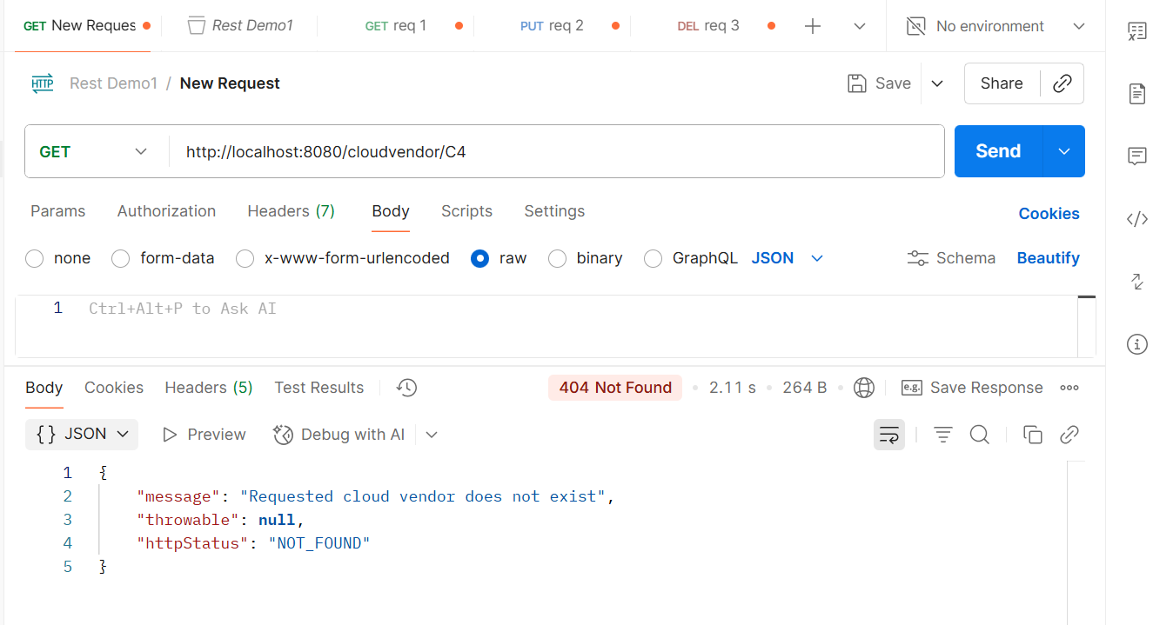
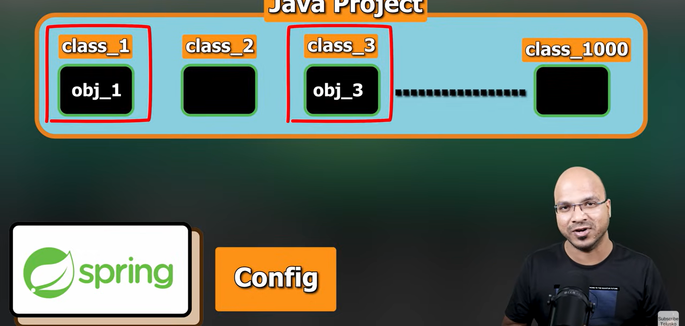
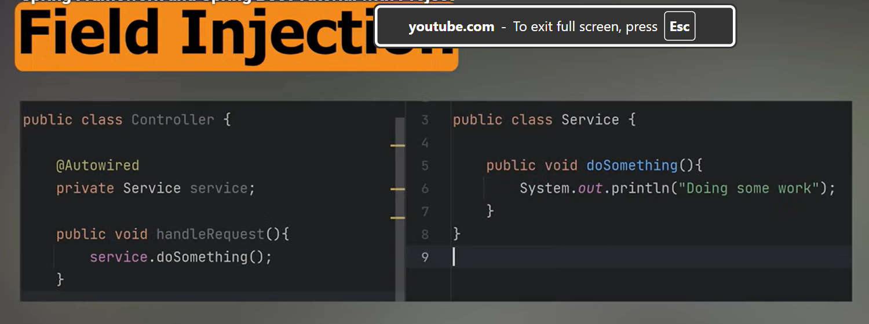
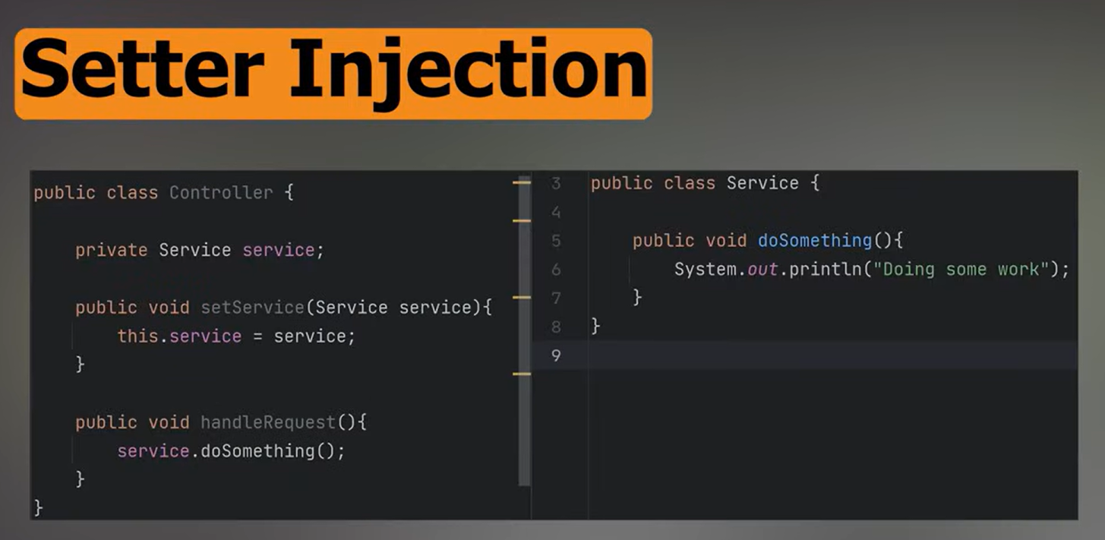

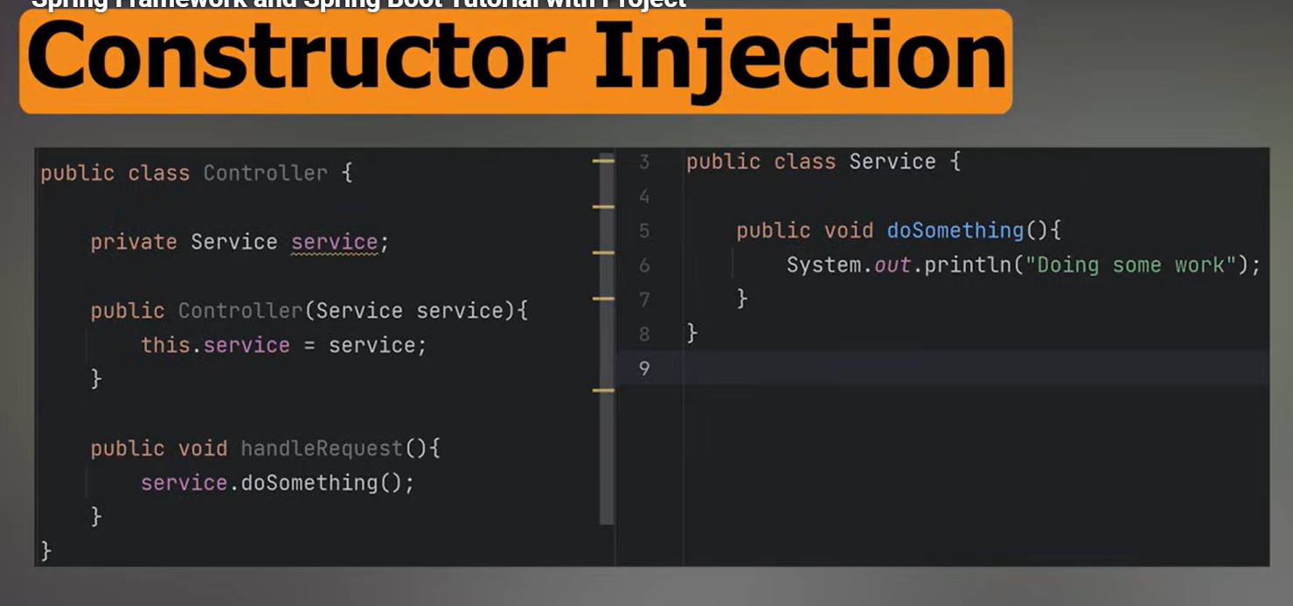
klj

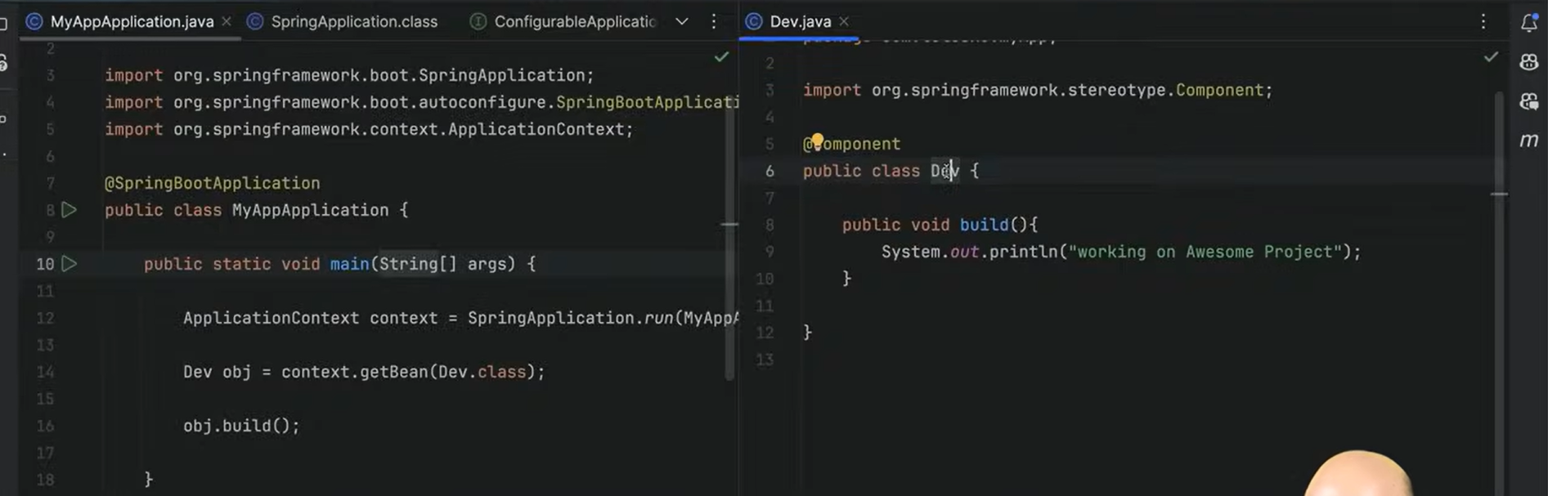
@autowired



